**Answer to the question number 1:**

* **The description about ecosystem and its importance for life on earth**
* An ecosystem is a community, where living things like animals, plants, organisms and microorganisms communicate with one another depending upon the environment such as water, air and soil etc. Ecosystem rules vary in different circumstances from ocean to small ponds to urban areas. Clean air, water, fertile soil, pollination of crops, nutrient cycling and climate regulation everything are included in ecosystem. The ecosystem is a part of biodiversity. The ecosystem plays an important role on earth. Because they provide basically food and shelter and protect against climate change. For life living on earth, a healthy ecosystem is a must.

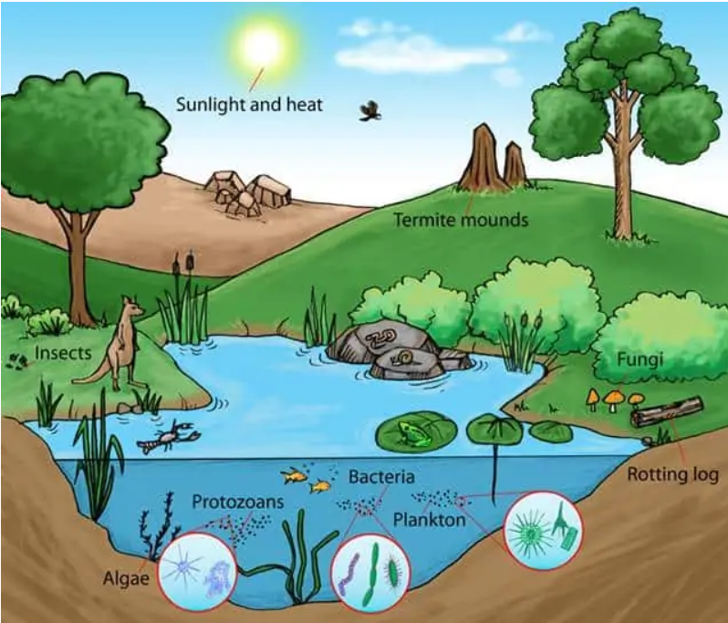

[Click here](https://www.zmescience.com/feature-post/natural-sciences/biology-reference/ecology-articles/ecosystems-what-they-are-and-why-they-are-important/)

* **Energy flows in an ecosystem and the role of primary producers.**
* An ecosystem’s energy cycle starts through photosynthesis when primary producers like algae plants and other bacteria capture soler energy. These primary producers transform solar radiation into chemical energy. After that it is stored as glucose, the food web’s base. Primary consumers (Herbivores) consume plants and are eaten by secondary consumers (carnivores). In each trophic level the energy transfers. The flow of energy is very much needed for the survival of living organisms. After that this energy transfer decreases at each level due to energy loss and heat. Primary producers are necessary for the constant influx of energy.

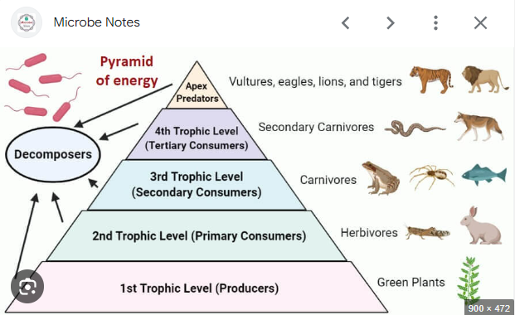

[**Click here**](https://microbenotes.com/pyramid-of-energy-definition-levels-importance-examples/)

* **The need to conserve ecosystem**
* Conserving ecosystem plays a significant role for maintaining biodiversity. It helps to maintain climate change, productive agriculture and prevent natural disasters. It ensures the availability of natural food, water and medicine to support biodiversity.
* Conserving the ecosystem is also important for sustainability. If the sustainability of ecosystem is damaged, the safety net of our environment will be weakened, and the vulnerable disasters will create problems. Conservation of ecosystem also means sustaining natural resources. For all these reasons, we need to conserve the ecosystem.
* **Man-made threats to ecosystem**
* **Deforestation:** Unfortunately, people are cutting down trees unnecessarily and that is why global warming is increasing day by day. It is damaging our biodiversity and water cycle model. Hughes (1983) mentioned that deforestation is the main reason for damaging ecosystems.

[**Click here**](https://earth.org/how-does-deforestation-affect-the-environment/)

* **Climate change:** We know that if the natural ecosystem is damaged then the temperature of the environment will increase. This climate change will threaten the ecosystem. People are using artificial elements instead of using natural elements. That is impacting in the climate.
* **Pollution:** Environment pollution is also a major threat for ecosystems. Because in these cases human beings destroy the natural ecosystem by polluting the natural elements and that impacts the environmental resources. Shaw (1921) mentioned that pollution is one of the major causes of destroying ecosystems.

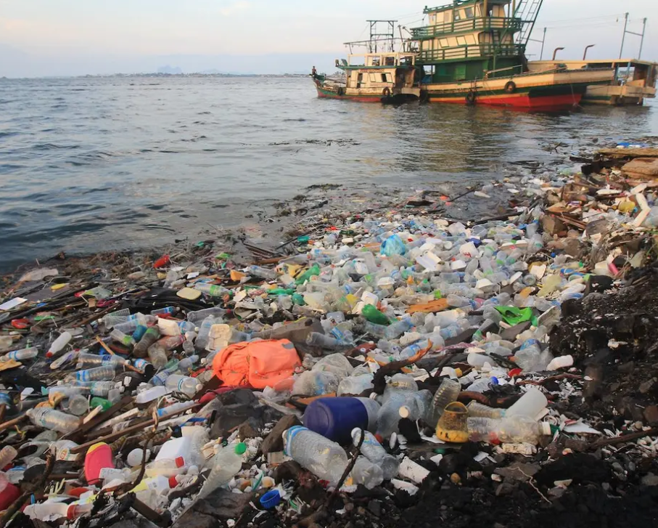

[Click here](https://www.earth.com/news/plastic-pollution-health-threats/)

* **Methods of conserving ecosystems and the challenges**
* **Sustainable resource management:** If we implement sustainable practice in agriculture, afforestation and fishing we can reduce habitat destruction.
  + - **Challenge:** Economic development and conservation goals are a big challenge for that.
* **Education and awareness:** Raising awareness for conservation of ecosystem among public will play a significant role in the society. If we suggest to the people about the advantages of preventing natural ecosystem, then all the major problems can be solved.
* **Challenge:** Educating people door to door is very challenging.
* **Protecting areas:** We should increase more and more national parks, reserves and marine protected areas to conserve habitat and species.
* **Challenge:** Less sufficient funding, good relation maintaining with the local community is very challenging.

**References:**

* Hughes, J. D. (1983). How the Ancients Viewed Deforestation. *Journal of Field Archaeology, 10*(4), 435-445. <https://www.jstor.org/stable/529466>
* Shaw, H. A. (1921). Greek Refugees from the Caucasus and the Work of the American Red Cross at Salonique. *The Journal of International Relations, 12*(1), 44-49. <https://www.jstor.org/stable/29738450>

**Answer to the question number 2:**

**Introduction to soil composition and its importance in agriculture.**

Soil is a natural resource which is mainly made up of different types of particles like water, air and other organic matters like sand, silt and clay. Soil basically consists of 25% water, 25% air, 5% other organic matter including plant materials, living organisms and microorganisms. The main essentiality of soil is to provide nutrients water, physical medium for agriculture. Soil fertilization is necessary for food production.

**Understanding soil erosion, natural and man-made causes:**

Soil erosion is basically done by evil humans. They use toxic substances and elements to produce crops in a hurry but unfortunately, they damage the environment. The top layer of soil is removed by wind, water and human unethical activities. As we know, the top layer is the basic soil profile because it has high nutrients for plant growth.

* **Natural causes of soil erosion:**
* **Water erosion:** Heavyrainfall, river overflow and flood can damage the topsoil especially in regions. Sipes (1999) mentioned that erosion of any natural substances of environment is a curse.
* **Wind erosion:** Strong winds can blow away the soil particles, especially in areas with little vegetation.
* **Wave erosion:** Coastal areas are mostly attacked by waves and tidal activities.
* **Human included causes of soil erosion:**
  + **Deforestation:** Deforestation is mainly caused by humans. Humans are cutting down trees unnecessarily. It is stabilizing the soil and increasing the risk of erosion.
  + **Improper Agricultural practices:** Over irrigation and heavy machinery can degrade the soil quality and increase erosion rate.
  + **Urbanization:** Urbanization is a major cause of land degradation. That is why the soil erosion rate is increasing day by day.

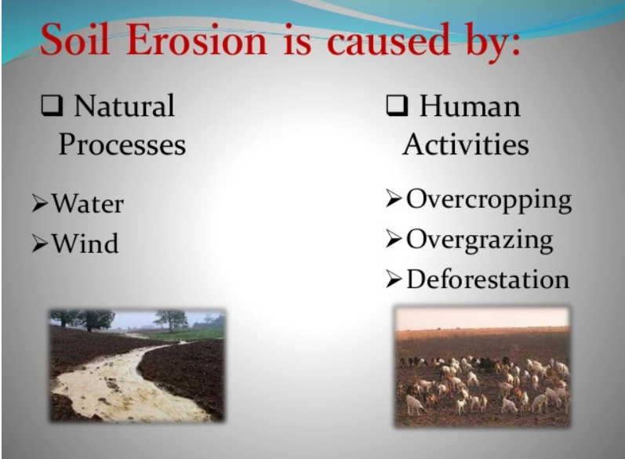

[**Click here**](https://eswar2001.wordpress.com/2018/06/26/soil-erosion-and-conservation/)

**Impact of soil erosion and agricultural practices:**

* **Reduced water retention capacity:** Erosion makes it harder for soil to hold water. Poor water retention stops the production rate and creates a vulnerable situation for agriculture.
* **Loss of topsoil:** Soil erosion removes the nutrient part of topsoil. For this reason, the farmers cannot grow productive food.
* **Increased dependency on fertilizers**: The farmerstry tocompensate for the crops by using chemical fertilizers. This can hamper our environment and increase costs.

[**Click here**](https://www.sciencedirect.com/topics/earth-and-planetary-sciences/soil-degradation)

**Mitigation methods for soil erosion and potential soil conservation plans:**

* **Agroforestry:** Planting trees and integrating shrubs into agricultural land can increase the nutrient rate of soil and the root system.
* **Vegetative buffer strips:** For protecting the water quality and reducing runoff planting more and more grasses and vegetation along waterways can trap sediments.
* **Cover Cropping:** For protecting soil erosion and enhancing soil structure, we need to plant cover crops like legumes between the main crops.
* **Conservation Tillage:** For preserving soil structure, we need to reduce tillage to maintain organic matter. Pratt (1910) mentioned that conservation of natural resources is necessary for globalization.
* **Plowing and Terracing:** Plowing and terracing can help to reduce runoff and can prevent soil.

[**Click here**](https://blog.eagronom.com/conservation-tillage-soil-health)

**Action plan for Soil Conservation in Bangladesh**

* **Improving flood management:** For developing and maintaining embankments and drainage systems we need to control flooding and reduce soil erosion.
* **Strengthen land using regulations:** We must enforce stricter regulations against deforestation and overgrazing.
* **Community involvement:** Wemust engage local communities in soil conservation by providing training. We must find resources for managing soil sustainability.

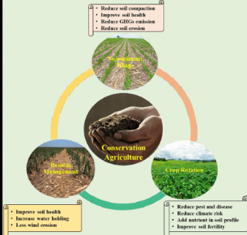

[**Click here**](https://www.researchgate.net/figure/Basic-principles-of-conservation-agriculture_fig1_353821337)

References:

* Pratt, J.H. (1910). THE CONSERVATION AND UTILIZATION OF OUR NATURAL RESOURCES. *Journal of the Elisha Mitchell Scientific Society,26*(1),1-25.<https://www.jstor.org/stable/24331163>
* Sipes, J. L. (1999). Erosion-Control Software. *Landscape Architecture, 89*(7), 40-45.<https://www.jstor.org/stable/44674730>